JOIN THE FIGHT FOR MIGRANT WORKER JUSTICE!

Panel with artists/activists about fightback campaigns

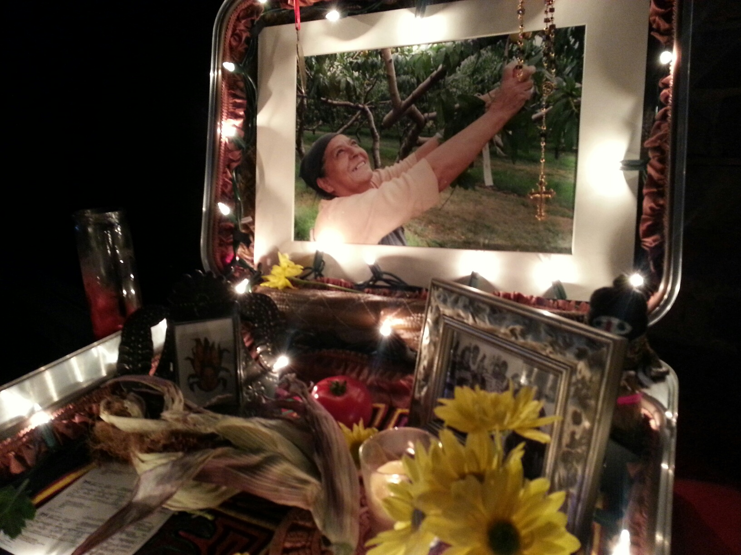

Wednesday October 23, 2013
12:45PM – 2:15 PM

Venue: Crossroads Gallery, FES Building, York University.

Featuring:

Chris Ramsaroop, Justicia for Migrant Workers

Farrah Miranda, No One Is Illegal

Min Sook Lee, Migrant Dreams

Sponsored by the Community Arts Program (CAP), the Centre for Feminist Research and the Centre for Research on Latin America and the Caribbean (CERLAC)

